**Mobile App Development**

Module Number:LD7026

Coursework Title:Share Landmark Mobile App

Module Tutor: Bilal Hassan

Student Name: Emdadur Rahman

Student Id: 20060771

Submission Date: 17 January 2022

Table of Content

**Part 1: Research …...……………………………………………….…………………….…… 5**

1.1 Mobile communication technology …...…………………………………………………… 6

1.1.1 3G …………….…………………………………..……………………………….………….………6

1.1.2 4G …………….…………………………………………..………………………………….……….6

1.1.3 5G …………….……………………………………………………….…..………………….……….7

1.2 Android framework vs. other development platforms ………………………………………7

1.2.1 Android vs. IOS ………………………………………………………....……………….7

1.2.2 Android vs. Blackberry…….……………………………………………………………….…….7

1.2.3 Android vs. Windows ……..………………………………………………………......................8

1.3 Features of different Android flavors ………………………………………………………. 8

**Part 2 Application Design …………………………………………………………………….. 9**

2.1 Application design ...…………………………………………………………………...........10

**Part 3** **Development …………………………………………………………………………...** 24

**Part 4** **Drployment …………………………………………………………………………….** 45

**References** ……………………………………………………………………………………... 47

List of Figure

1. Figure 2.1: App Flow………………………………………………….…………………10
2. Figure 2.2: Data Flow………………………………………………….…………………11
3. Figure 2.3: Sign In…………………….………………………………………………12
4. Figure 2.4: Sign Up………………………...…………………………………………12
5. Figure 2.5: Forgot Password…………………...……………………………………13
6. Figure 2.6: My Places…………………………………...……………………………13
7. Figure 2.7: Add Tourist Place…………………………………….…………………14
8. Figure 2.8: Notification………………………………………………………………14
9. Figure 2.9: Drawer………………………………………………….…………………15
10. Figure 2.10: Tourist Place Details…………………………………………….……16
11. Figure 2.11: Edit Tourist Place…………………………………….………………..17
12. Figure 2.12: Profile…………………………………………………….………….…..17
13. Figure 2.13: Edit Profile……………………………………………….…………..…18
14. Figure 2.14: Notification Prompt…………………………………….………..……18
15. Figure 2.15: Collection of Notification in the database…………………….……….……19
16. Figure 2.16: Collection of Place Data in the database ……………………….…..………19
17. Figure 2.17: Collection of Post in the database……………………………….……..……20
18. Figure 2.18: Collection of User in the database……………………………….……….…20
19. Figure 2.19: Place Model Class…………………………………………..…………22
20. Figure 2.20: Notification Model Class…………………………………..…………22
21. Figure 2.21: Post Model Class……………………………………………....………23
22. Figure 2.22: User Model Class……………………………………………...………23
23. Figure 3.1: Minimum and Target Android SDK………………………...………25
24. Figure 3.2: App Navigation…………………………………………………………25
25. Figure 3.3: App Navigation…………………………………………………………26
26. Figure 3.4: Get Location Permission Code………………………………….……26
27. Figure 3.5: Get Location Permission………………………………………………27
28. Figure 3.6: Sign Up Page…………………………………………………….………28
29. Figure 3.7: Sign In Page…………..………………………………………….………28
30. Figure 3.8: Input Validation……..……………………….………………….………29
31. Figure 3.9: Input Validation Code Snippet……….………………………………30
32. Figure 3.10: Input Validation Code Snippet…………...…………………………30
33. Figure 3.11: Password Change………………………………………………...……31
34. Figure 3.12: Home page ……………………………………………..…………………32
35. Figure 3.13: Description of palace ……………………………………………….……33
36. Figure 3.14: Ratings and Review of Place…………………………………………..…33
37. Figure 3.15: Add Place…………………………………………………………….… 34
38. Figure 3.16: Location Description……………………………………………….. 34
39. Figure 3.17: Profile Page………………………………………………………..… 35
40. Figure 3.18: Edit Profile…………………………………………………...……… 36
41. Figure 3.19: My Place………………………………………………………………… 37
42. Figure 3.20: Notification Page…………………………………………………… 38
43. Figure 3.21: Notification from the App ………………………………………………..38
44. Figure 3.22: Search Options………………………………………………………… 39
45. Figure 3.23: L Search Options…………………………………………………..……39
46. Figure 3.24: Sharing Option……………………………………………………..…40
47. Figure 3.25: Settings Option…………………………………………………….…….…41
48. Figure 3.26: Sharing Option………………………………………………..…….…42
49. Figure 3.27: Privacy Policy…………………………………………………………43
50. Figure 4.1: Add App on The Play Console Dashboard……………………..… 45
51. Figure 4.2: App release steps………………………………………………….……45
52. Figure 4.3: App release steps………………………………………………..…..…46
53. Figure 4.4: Uploading App Bundle On The Google Play Console………….46
54. Figure 4.5: App in Review for Publish………………………………..………….47
55. Figure 4.6: App published in Google Play store…………………………….…..47

**Part 1**

**Research**

# Part 1

## Mobile communication technology

Mobile communication is an inseparable part of the modern communication process, with the increase in advanced technology; mobile communication shows an increasing dimension and optimization (Ibrahim and Abdullah, 2017). A mobile phone is a bidirectional radio which enables two-way communications such as reception and transmission. The geographic divisions of telecommunication in the cell a within the cell is their basis of mobile communication. Mobile communication is envelope over the year from 2G to now it time to 5G.

* + 1. **3G**

3G networks based on the single frequency wideband networks. 3G mobile operates through the same wideband frequency and interface. So, the signal-to-noise-ratio (SNR) is an important factor for the 3G connection. There latency of the 3G network is 100-500 ms and the maximum downloading speed is 42 Mbps.

* + 1. **4G**

The operation of the 4G networks is as same as the 3G networks which means it is also has single frequency wideband. The maximum data transfer rate can be achieved by minimizing the interface and the overlap. There latency of the 4G network is about 10ms.

* + 1. **5G**

The standardization process of 5G mobile network is under process. The allocated frequency of the 5G networks is higher than the 3G and 4G networks. The propagation of the signals decreases by increasing the frequency (Bai *et al.* 2021). The frequency range of the 5G networks is between 700 MHz and 3500 MHz The 5G networks will bring the revolution in the communication sectors, which will offer height speed and lowest latency.

## 1.2 Android framework vs. other development platforms

Androids framework is widely used by smart phones programmers because it is worthy and easier to use. There are other development platforms such as IOS, Blackberry, and Windows. Tables 1, 2, and 3 compare and contrast the features of the Android framework with other development frameworks.

* + 1. **Android vs. IOS**

| **Android** | **IOS** |
| --- | --- |
| * Android is the widely used Smartphone platform across the world used by various manufacturers such as Samsung, HTC, LG, etc. * Androids are mostly programmed in C++, C, and JAVA. The Software Development Kit (SDK) is easily available free of cost. | * IOS is also the leading market player like Android but it is only used in the devices of Apple such as iPad, Apple TV, iTouch, etc. * The Developer needs to pay to access the iOS SDK. |

**Table 1: Android vs. IOS**

(Source: Self-created)

* + 1. **Android vs. Blackberry**

| **Android** | **Blackberry** |
| --- | --- |
| * For game apps, Android is the dedicated player. * It is an open-source platform so there is a security issue. | * Blackberry provides a strong communication network. * It is much secure because Blackberry used its own server |

**Table 2: Android vs. Blackberry**

(Source: Self-created)

* + 1. **Android vs. Windows**

| **Android** | **Windows** |
| --- | --- |
| * Android Operating System is used in Android devices and it is an open-source platform. * The security is less as compared to Windows because apps can register themselves to support and share data to process inter-communication. | * Windows Operating System is used in Windows phones and it is a mix of closed and open source. * The security of Windows is comparatively high as every app needs to open the sandbox. |

**Table 3: Android vs. Windows**

(Source: Self-created)

## 1.3 Features of different Android flavours

The variant of the Androids app is called Android flavor, which means with single codebase different versions of an app can be developed (Hussain *et al.* 2018). Products flavors are the features of the Gradle plugin offered by Android Studio, with the help of this different customized versions of the products can be possible create.

# 

**Part 2**

**Application Design**

# Part 2

* 1. **Application design**

The application is designed to attract the tourist in various destinations around the UK in attention to increase the traveler gather rating and to promote the tourist destination. The application is designed by the fulfillment of every requirement of the government agency.

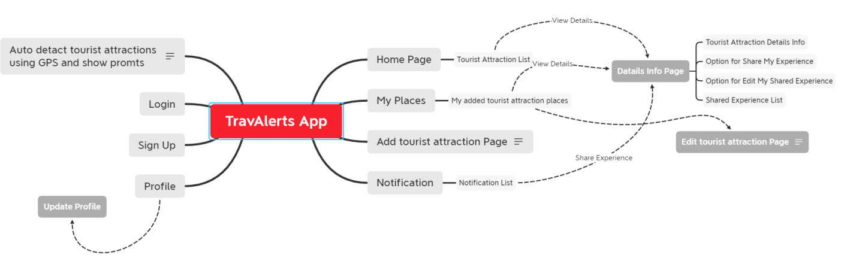

**Figure 2.1: App Flow**

**(**Source: self-created with Xmind**)**

The above figure 2.1 represents the flow of the app. The app will started with auto detect tourist attraction by using the GPS and show prompt. It has signup and login option for the anonymous visitor of the app, TravAlert. It has profile for the registered visitors of the app. Then there is Home Page, My places, Tourist Attraction Page, and Notification.

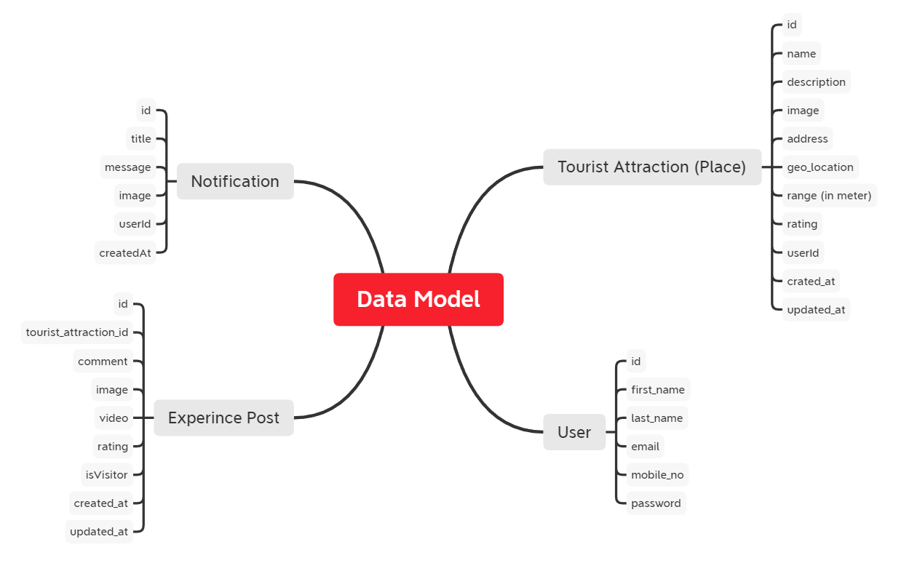

**Figure 2.2: Data Flow**

(Source: Self-created with Xmind)

The above figure 2.2 represents the data flow model of the app. It has Notification, Experience Post, User, Tourist Attraction (Place) entities. All the entity has different characteristics. Notification has 6 characteristics such as id, title, message, image, userId, and createdAt. Experience Post has id, tourist_attraction_id, comment, video, rationg, image, isVisitor, upddated_at, and createdAt. Tourist Attraction (Place) entity has id, name, description, image, address, geo_location, range (in meter), rating, userId, upddated_at, and createdAt. User entity has id, first_name, last_name, email, mobile_no, and password.

|  |  |
| --- | --- |
| Figure 2.3: Sign In  (Source: Self-created with Balsamiq) | Figure 2.4: Sign Up  (Source: Self-created with Balsamiq) |

|  |  |
| --- | --- |
| Figure 2.5: Forgot Password  (Source: Self-created with Balsamiq) | Figure 2.6: My Places  (Source: Self-created with Balsamiq) |

|  |  |
| --- | --- |
| Figure 2.7: Add Tourist Place  (Source: Self-created with Balsamiq) | Figure 2.8: Notification  (Source: Self-created with Balsamiq) |

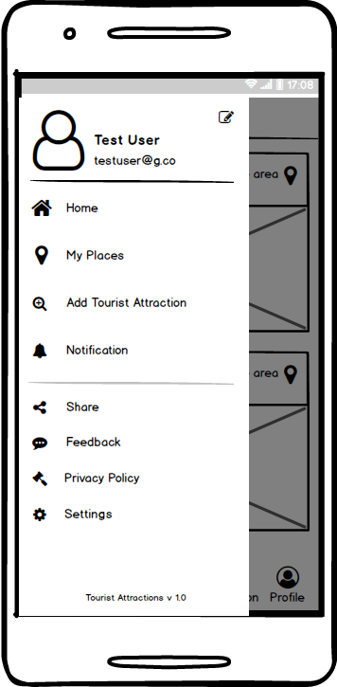

Figure 2.9: Drawer

(Source: Self-created with Balsamiq)

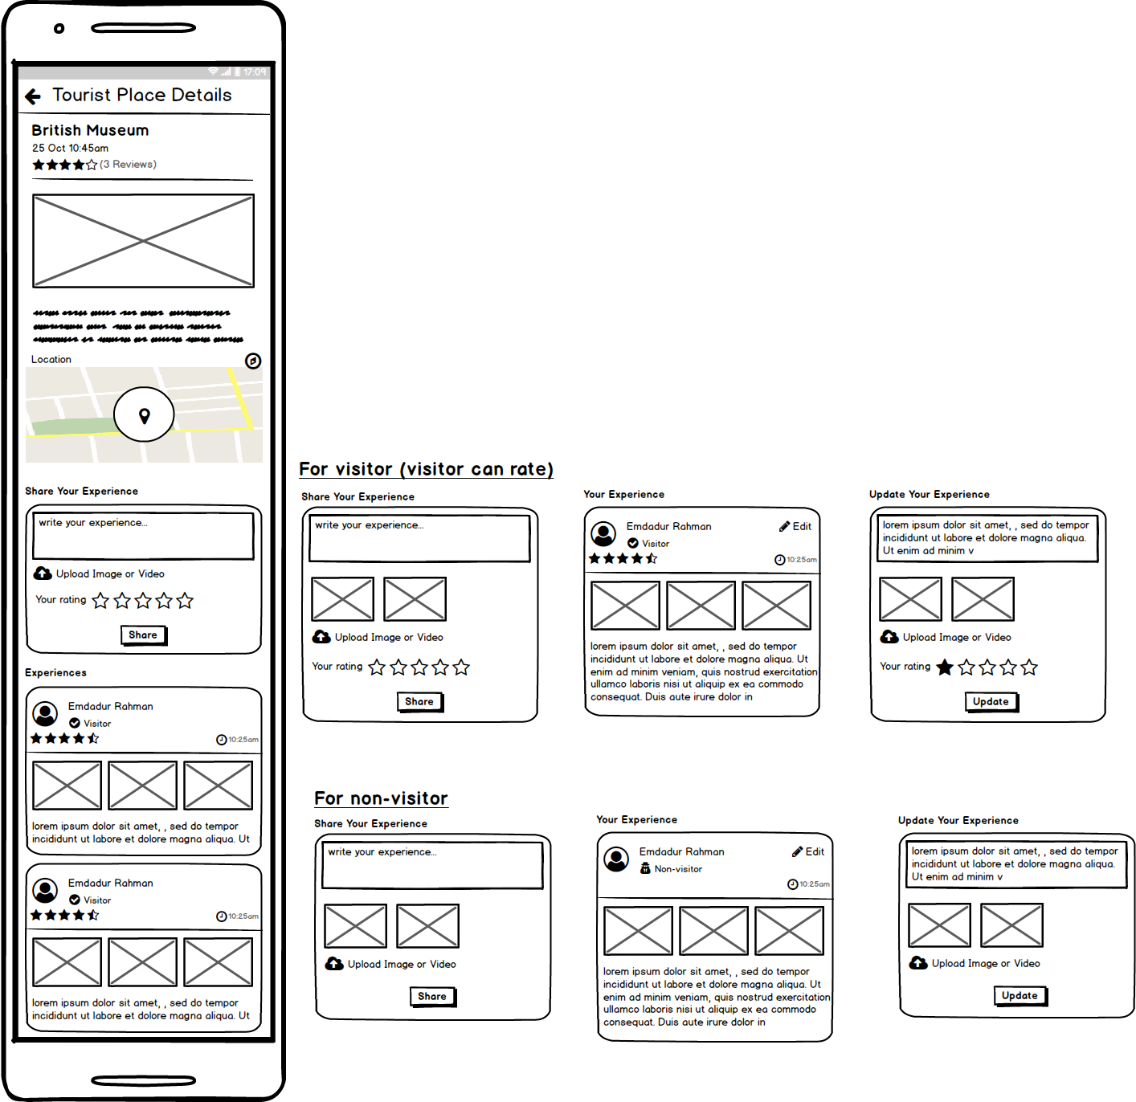

Figure 2.10: Tourist Place Details

(Source: Self-created with Balsamiq)

|  |  |
| --- | --- |
| Figure 2.11: Edit Tourist Place  (Source: Self-created with Balsamiq) | Figure 2.12: Profile  (Source: Self-created with Balsamiq) |

|  |  |
| --- | --- |
| Figure 2.13: Edit Profile  (Source: Self-created with Balsamiq) | Figure 2.14: Notification Prompt  (Source: Self-created with Balsamiq) |

Figure 2.3 to 2.14 represents wireframes which is illustration of apps interface pages.

These are blueprint (low-fidelity structural representation) of the app’s layout.

Wireframes are designed with Balsamic.

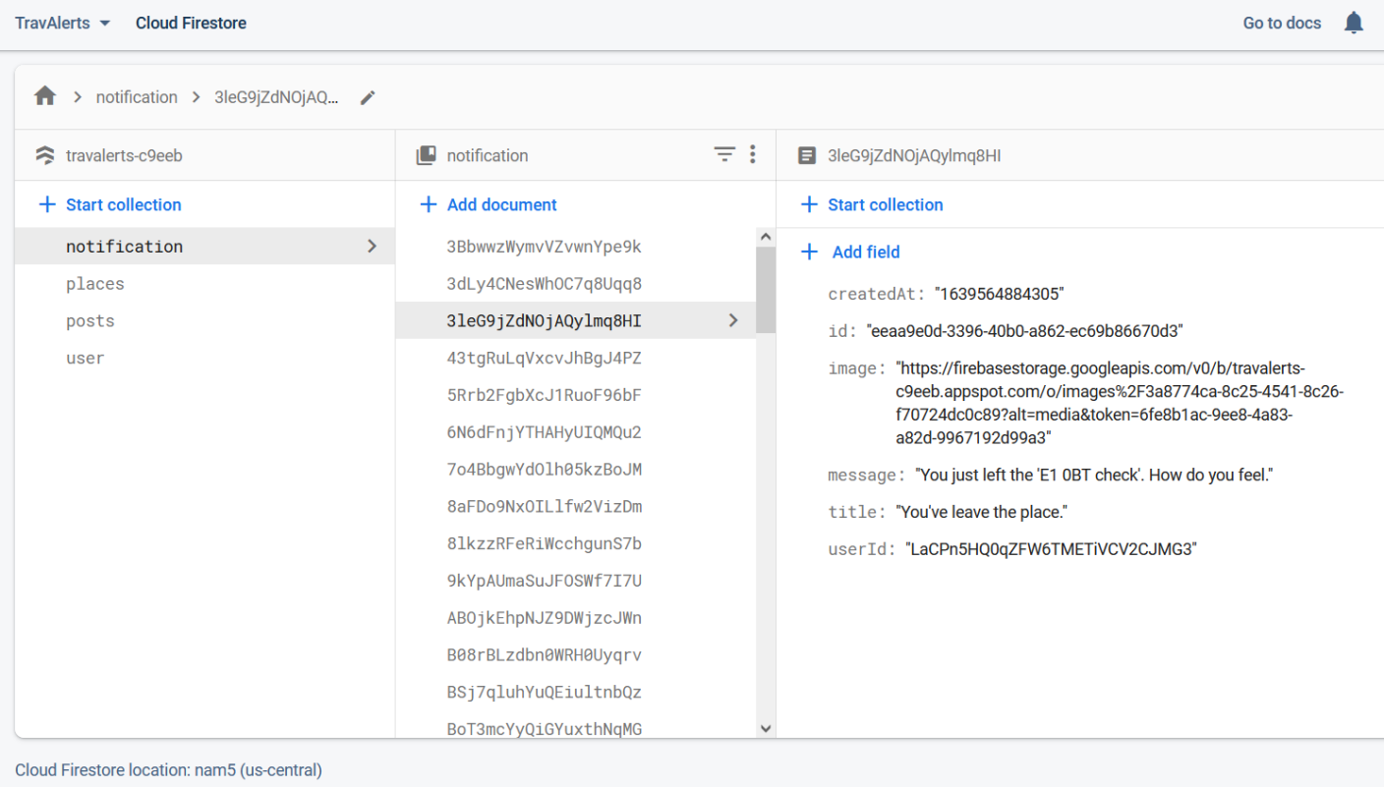

Figure 2.15: Collection of Notification in the database

(Source: Firebase Screenshot)

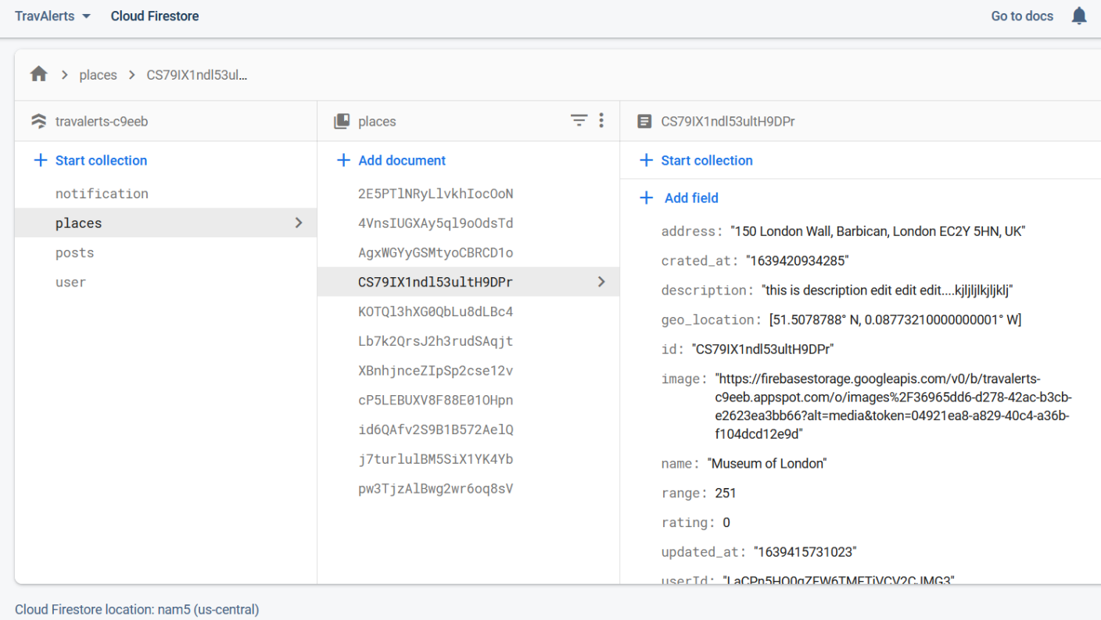Figure 2.16: Collection of Place Data in the database

(Source: Firebase Screenshot)

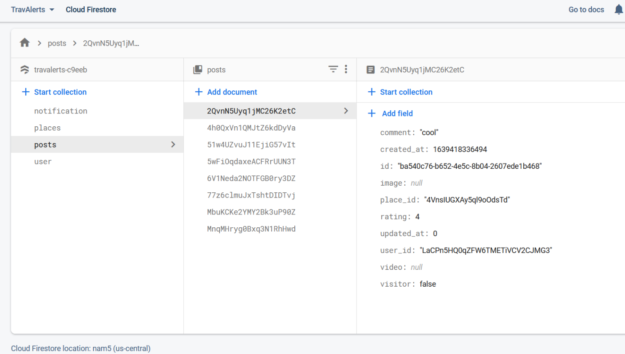Figure 2.17: Collection of Post in the database

(Source: Firebase Screenshot)

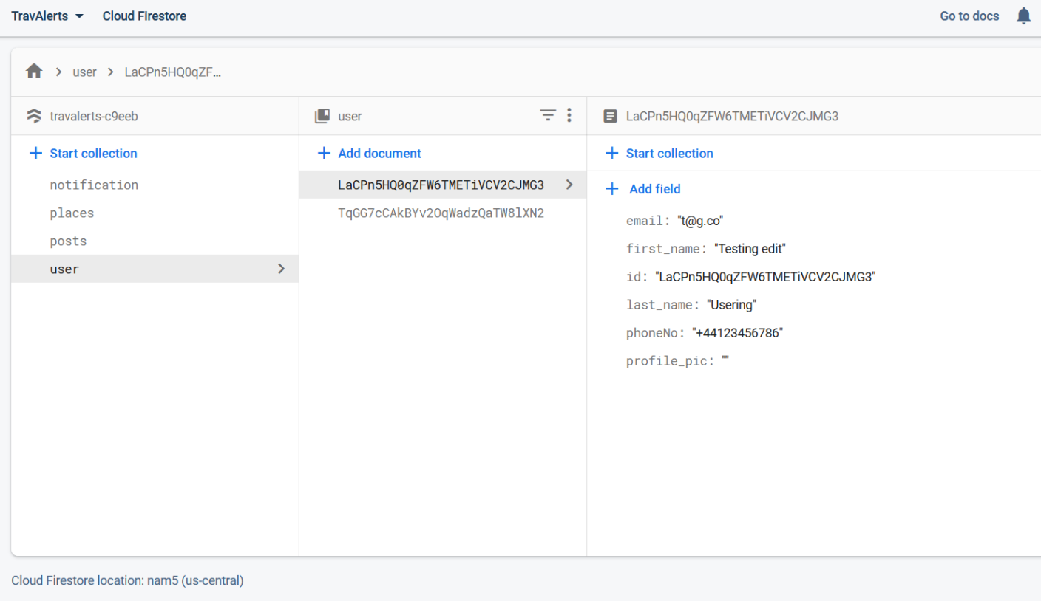

Figure 2.18: Collection of User in the database

(Source: Firebase Screenshot)

The above figure 2.15, 2.16, 2.17, and 2.18 represents collections of the data in the database. All of the figures show the location of all the data such as Notification, Experience Post, User, Tourist Attraction (Place) entities. Every entity has unique location id and a title. In the notification entity a message will show as “You just left the place name” with a title “You have leaved the place”. Every place which the visitors are visits are stores in the app with different entities. In the address entity the address if the location where the user visits with a unique id, geo location. It is also saving the images and name of the tourist spots, there is option where visitors can rate the spots. The visitors can post the image of the palace from the live location with comments, which will save in the app with ratings, times, userId. In the app different details of the user also stores such as email, name, phone number, and profile picture.

The app is design with considering all the ethical and social consideration. There is no personal data of the user stores in this app as shown in the above dataflow model and figures. It is very important to maintain all the ethical and social consideration because it is a government app and is needs to be extra careful about the interest of the common people.

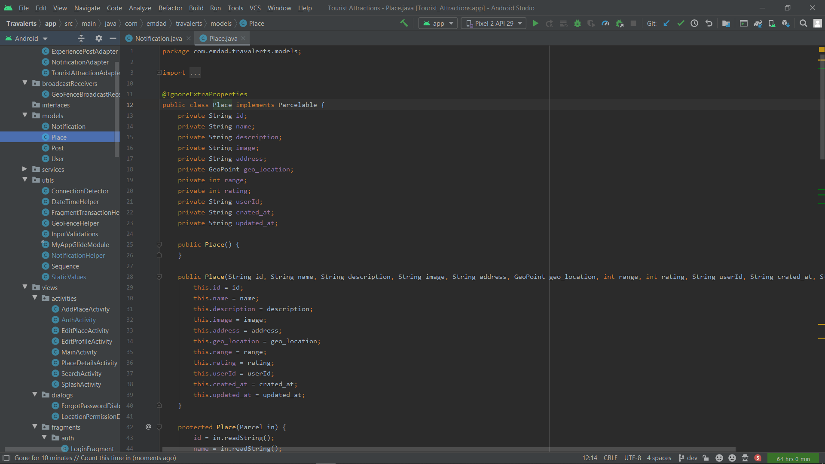

Figure 2.19: Place Model Class

(Source: App Code Snippets)

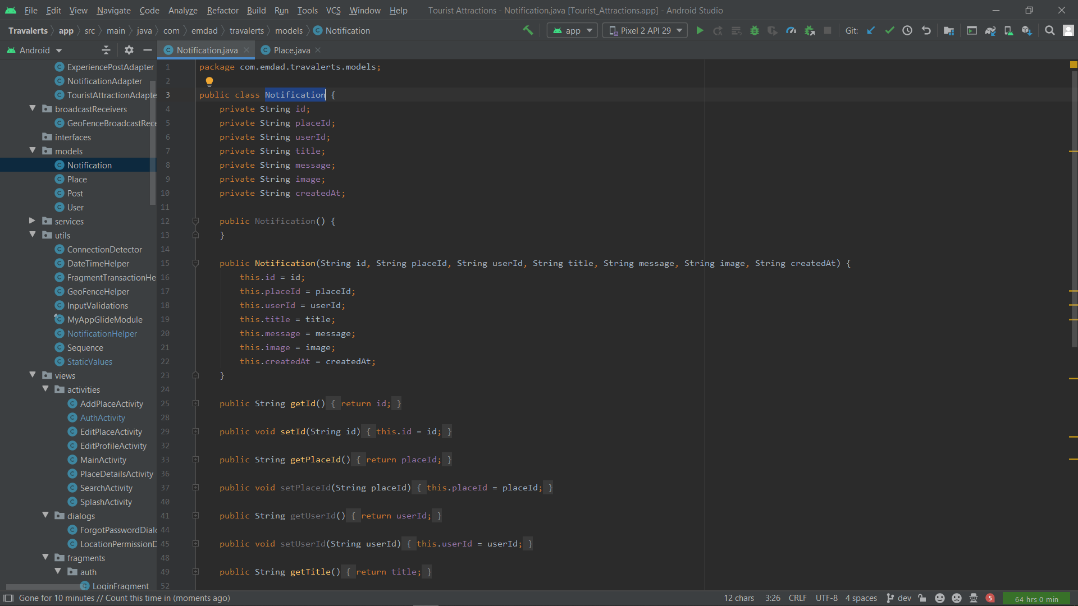

Figure 2.20: Notification Model Class

(Source: App Code Snippets)

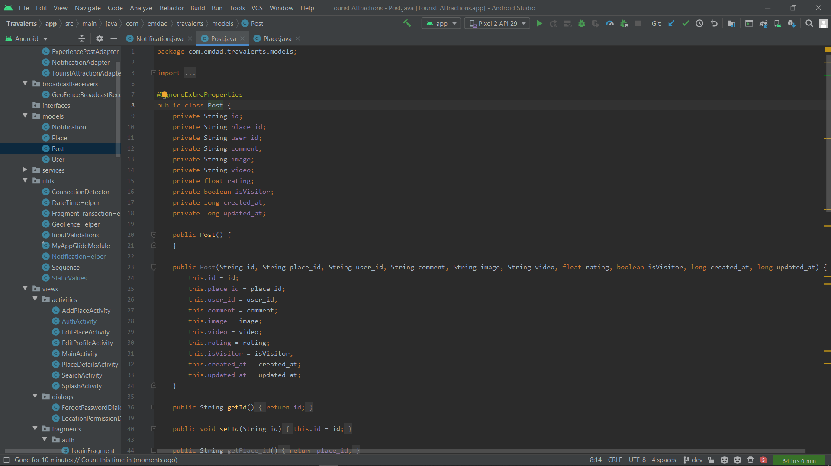

Figure 2.21: Post Model Class

(Source: App Code Snippets)

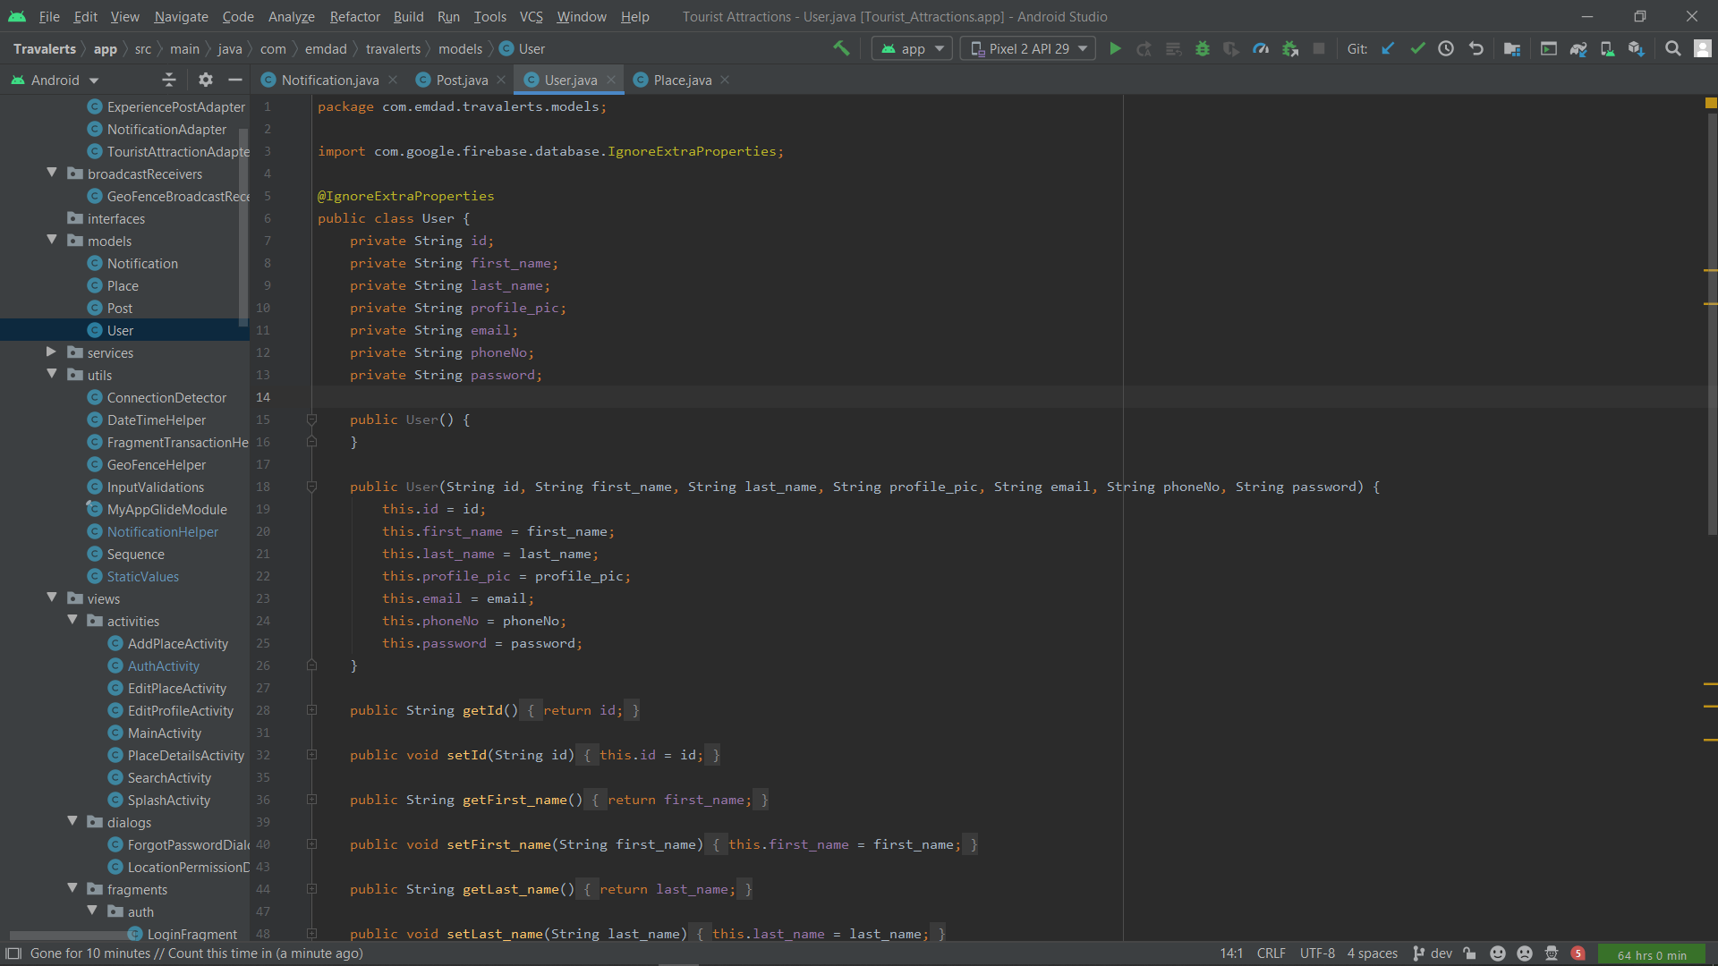

Figure 2.22: User Model Class

(Source: App Code Snippets)

The above figure 2.19, 2.20, 2.21, and 2.22 represents collections of the data model classes that are structured according to app need.

**Part 3**

**DEVELOPMENT**

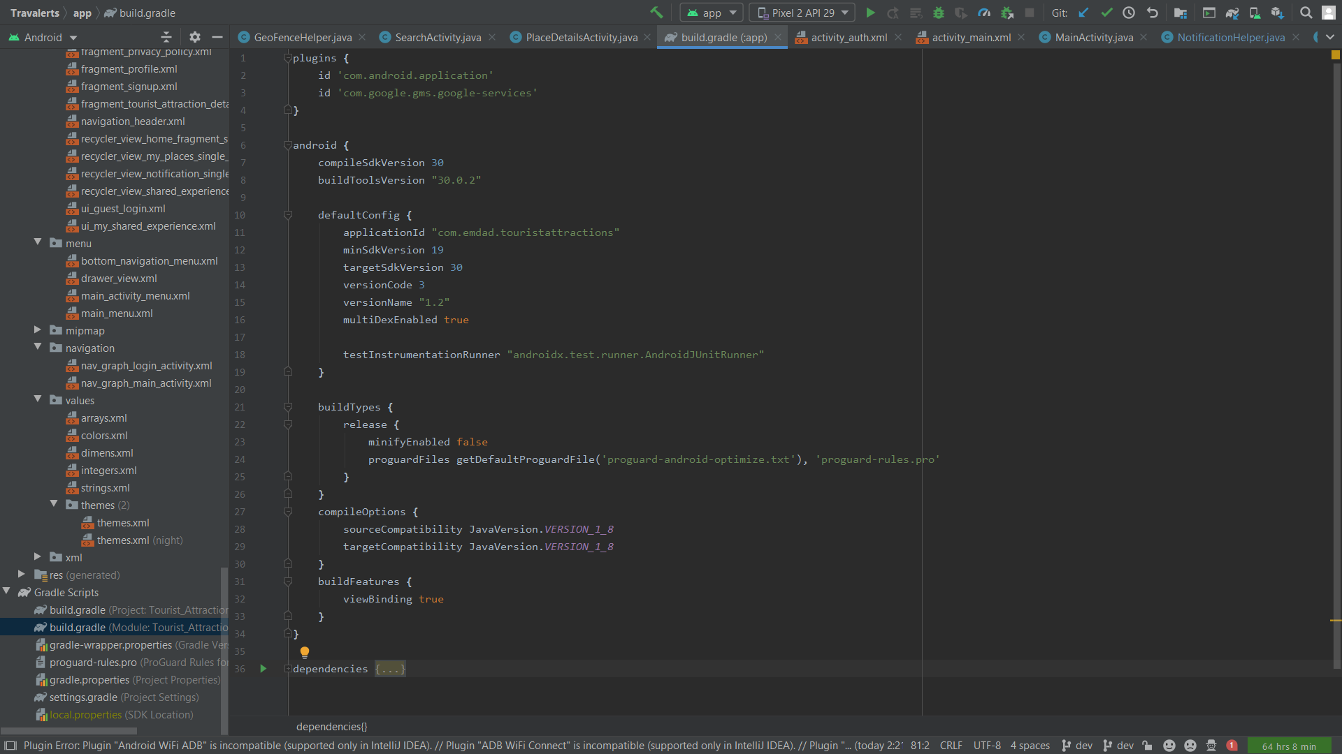

Figure 3.1: Minimum and Target Android SDK

(Source: Code Snapshot from Android Studio)

The above figure 3.1 shows the minimum and targeted Android SDK version to run on compatible devices

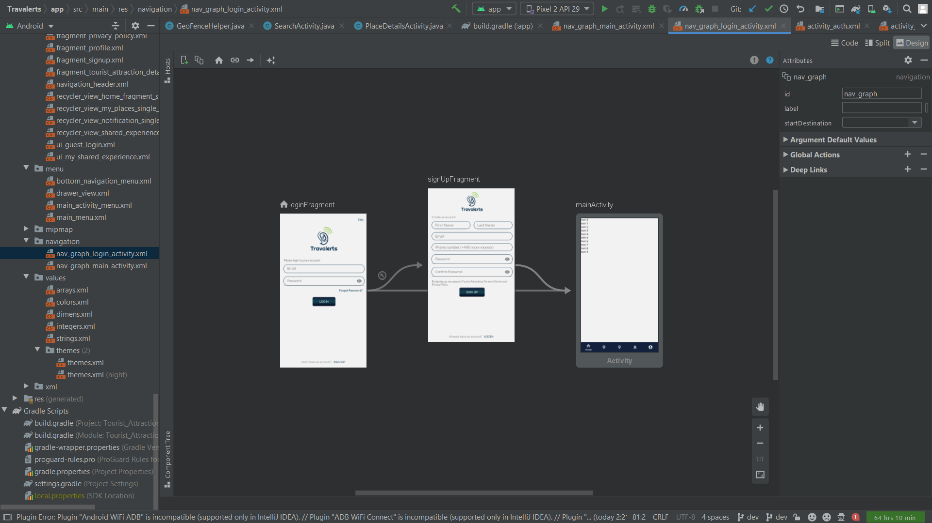

Figure 3.2: App Navigation

(Source: Snapshot from Android Studio)

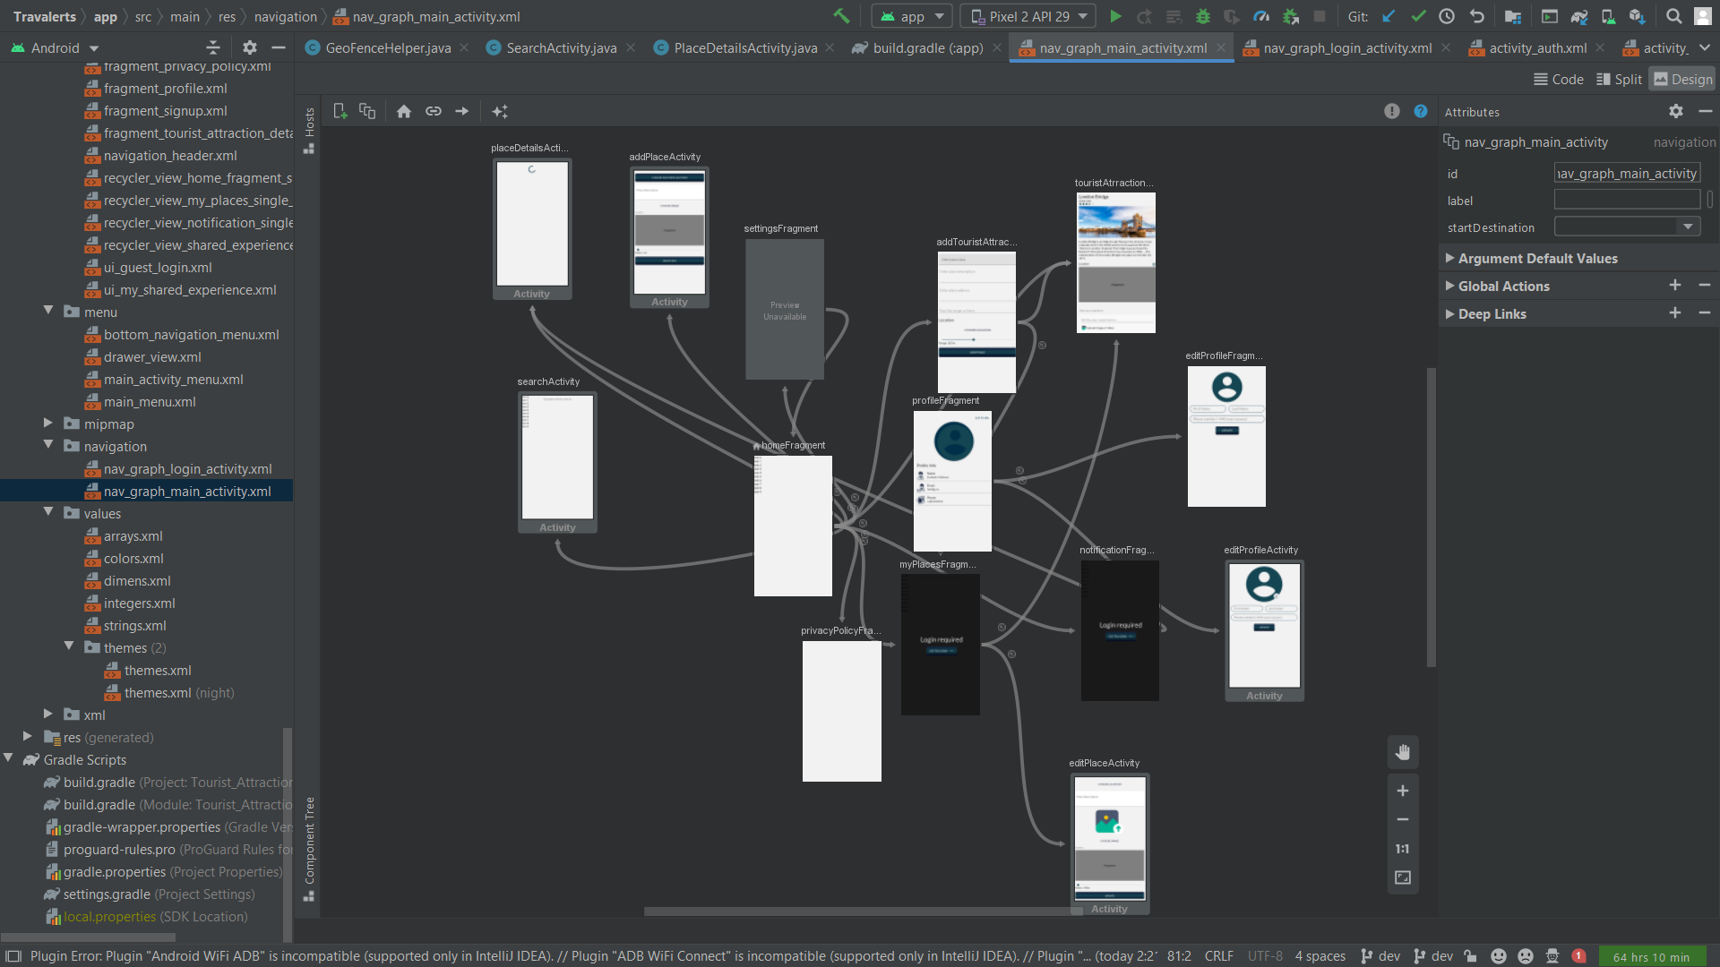

Figure 3.3: App Navigation

(Source: Snapshot from Android Studio)

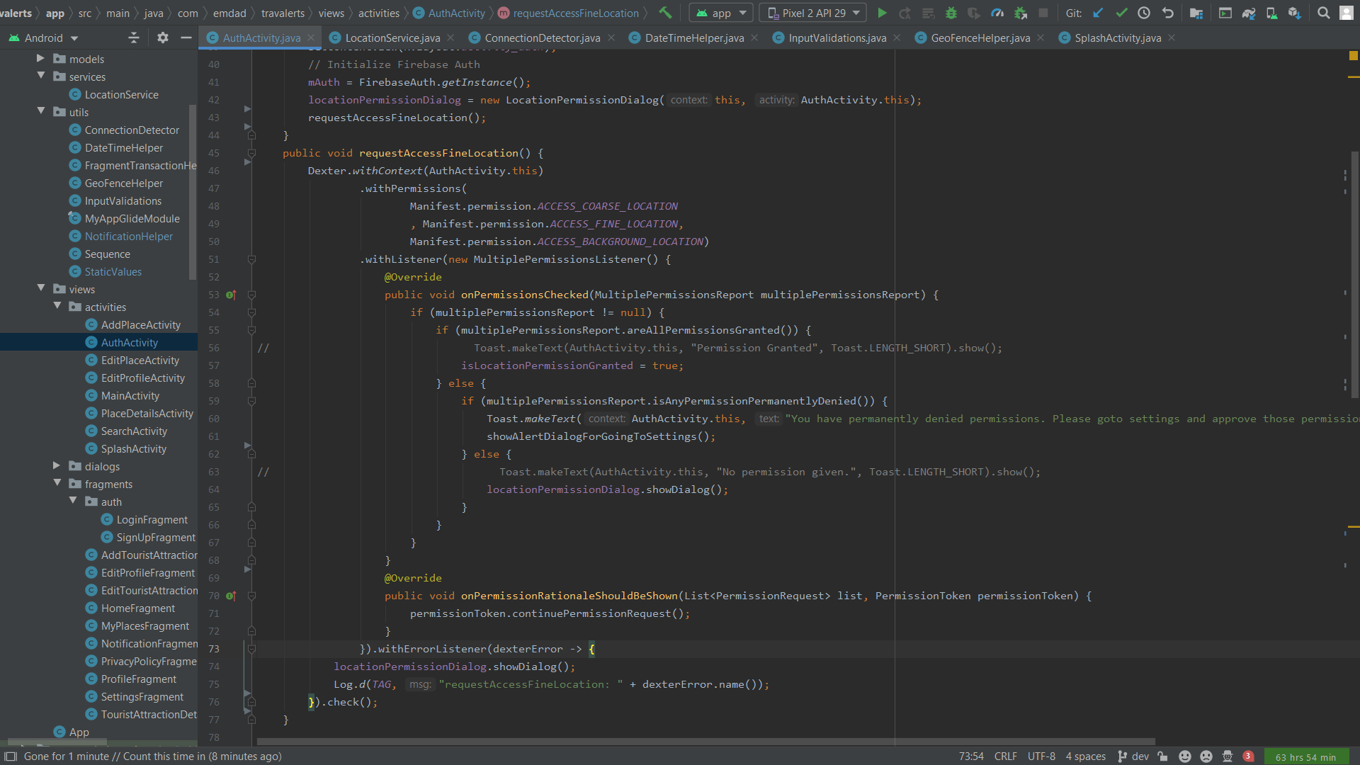

Figure 3.4: Get Location Permission Code

(Source: App Screenshot)

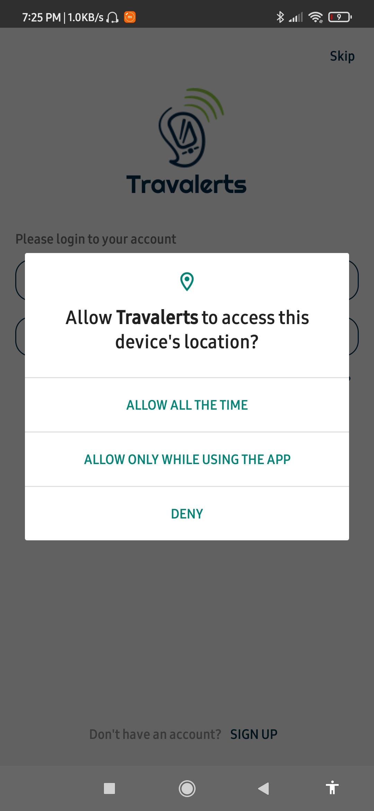

Figure 3.5: Get Location Permission

(Source: Self-created)

The above two figures 3.4 and 3.5 shows the code snippet and dialog that is actually responsible for taking user location permission with dialog at the start of the app launch, however it is mandatory for the user to let the app use location permission in order to use the app.

|  |  |
| --- | --- |
| Figure 3.6: Sign Up Page  (Source: Self-created) | Figure 3.7: Sign In Page  (Source: Self-created) |

The above figures 3.6 shows the Sign Up Page for new user of the app where people can sign up the app by giving various details such as first name, last name, mobile number, password and confirm password. The existing users can directly login to the app by giving their email and password as shown in figure 3.7.

|  |  |
| --- | --- |
|  |  |
|  |  |

Figure 3.8: Input Validation

(Source: App Screenshot)

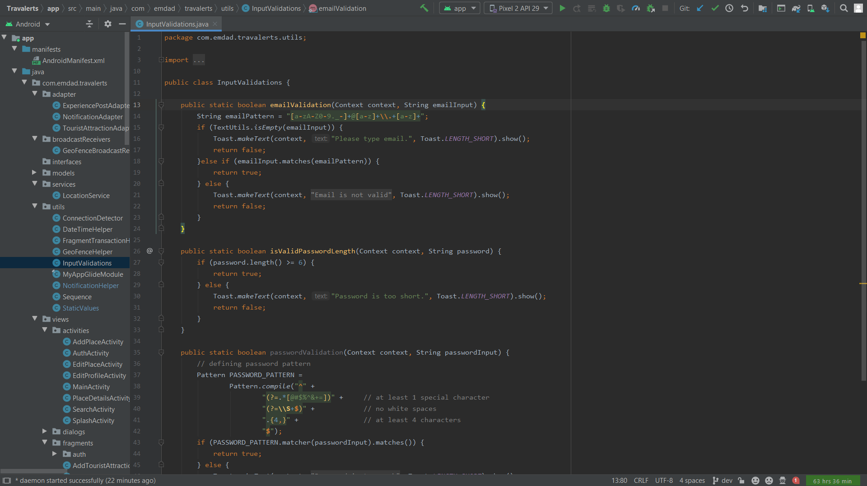

Figure 3.9: Input Validation Code Snippet

(Source: App Screenshot)

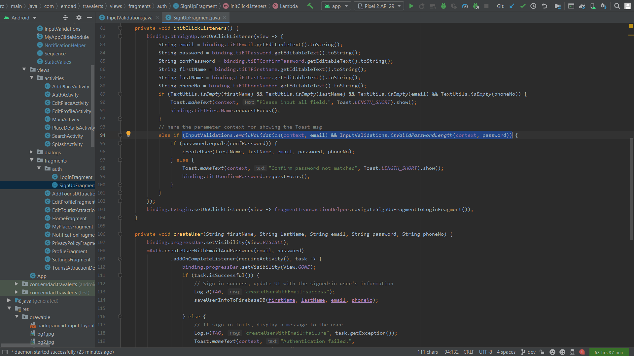

Figure 3.10: Input Validation Code Snippet

(Source: App Screenshot)

Above three figures 3.8, 3.9 and 3.10 shows input validation functional UI and code snippets that typically checks the values of input fields to ensure that they contain valid name, email, password or correct set of characters to avoid errors.

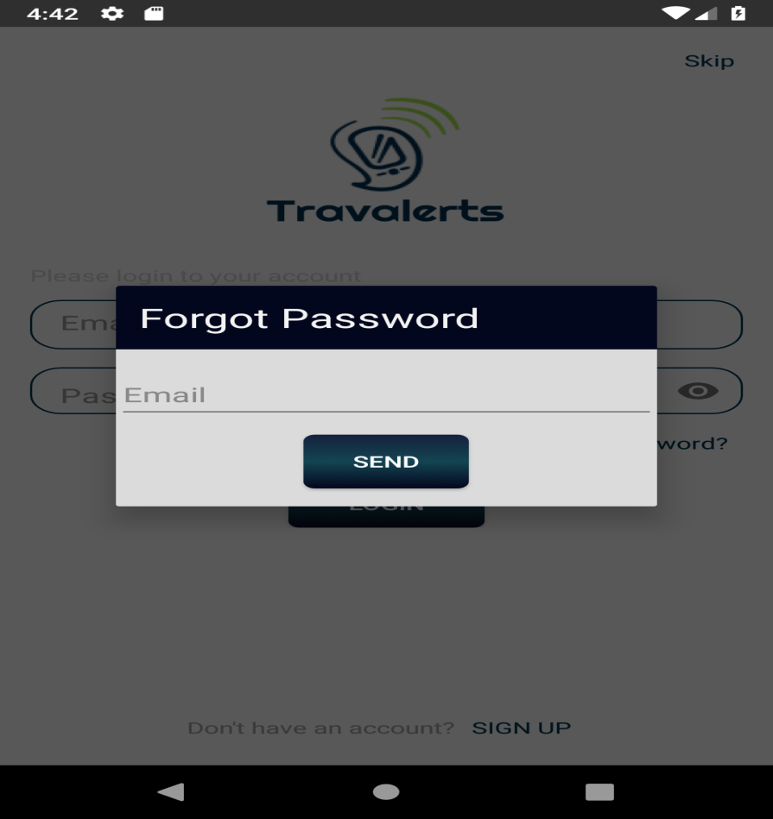

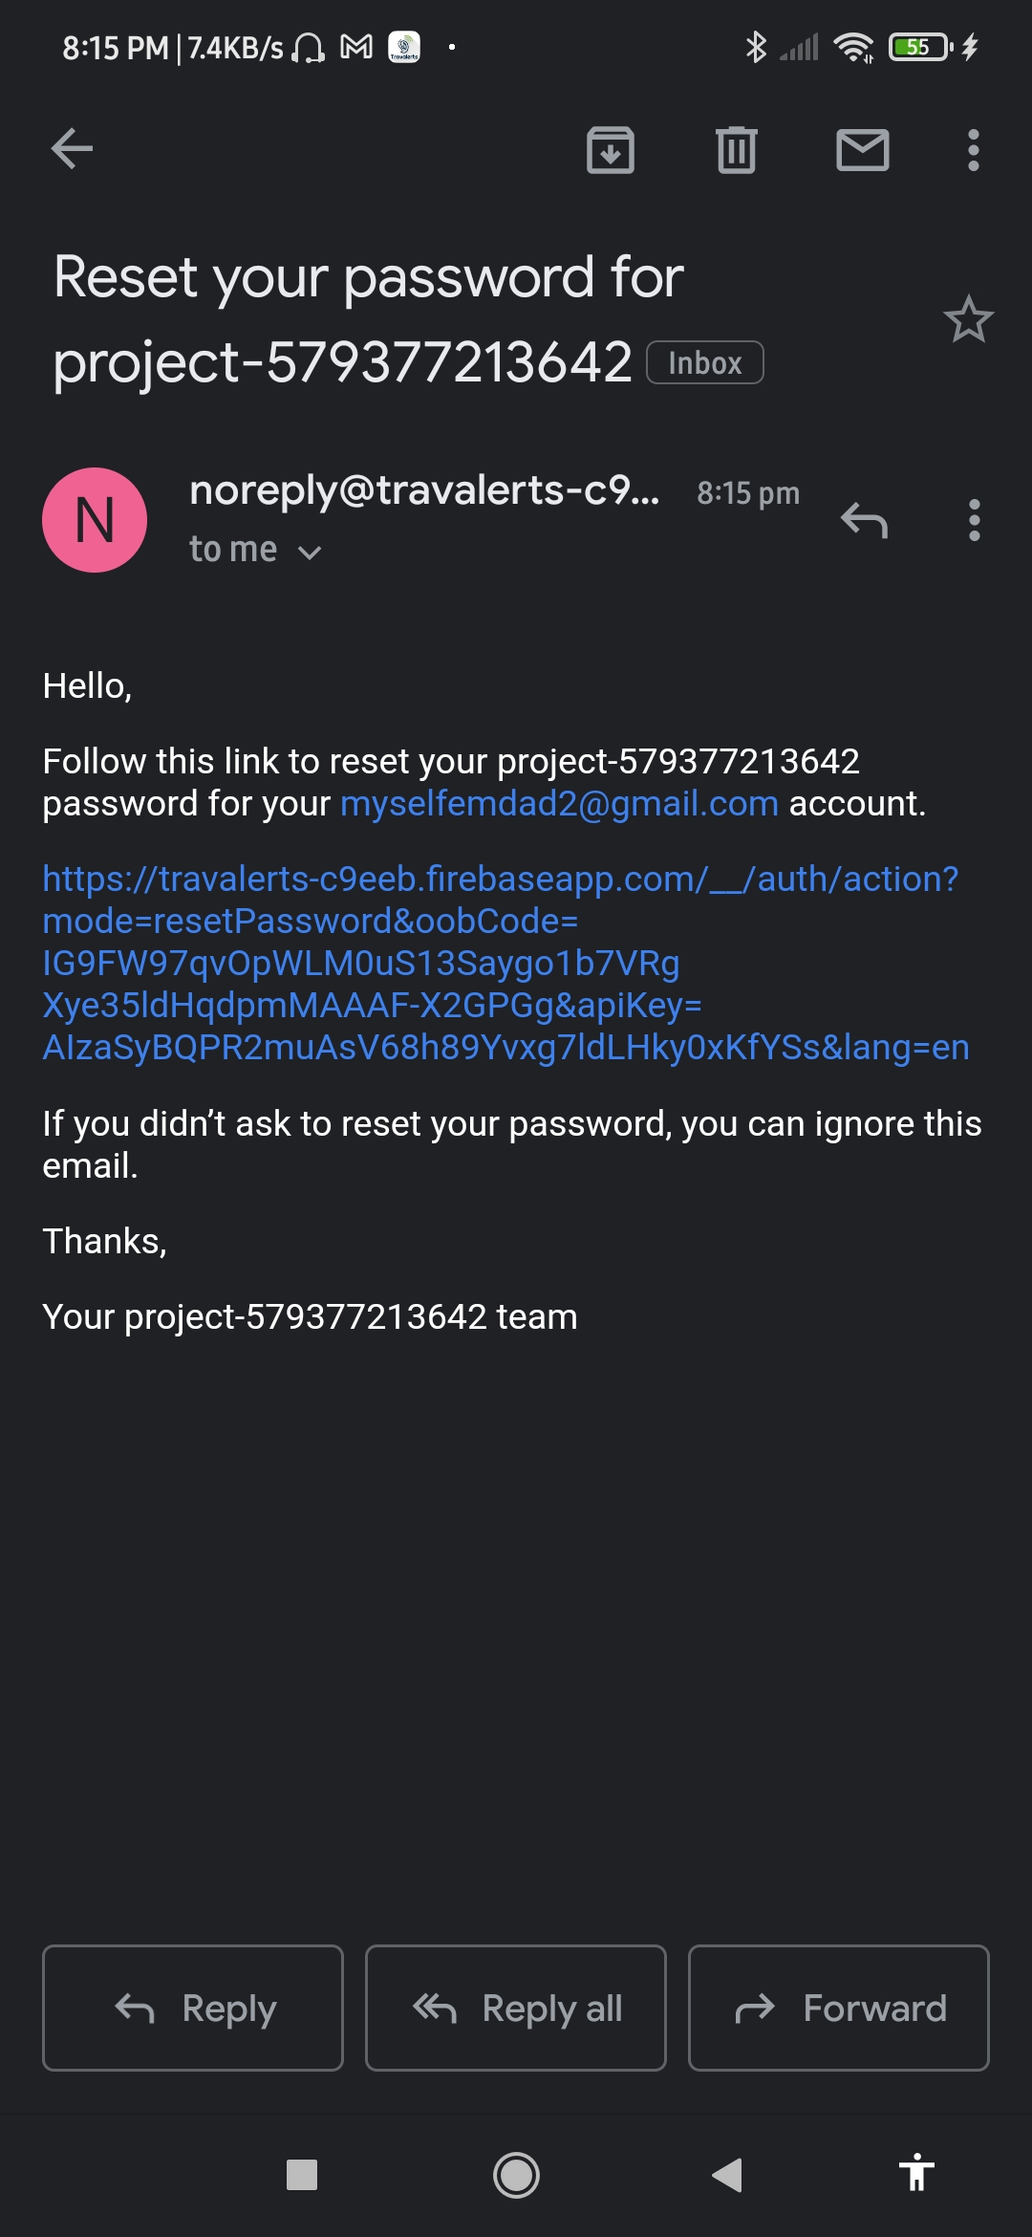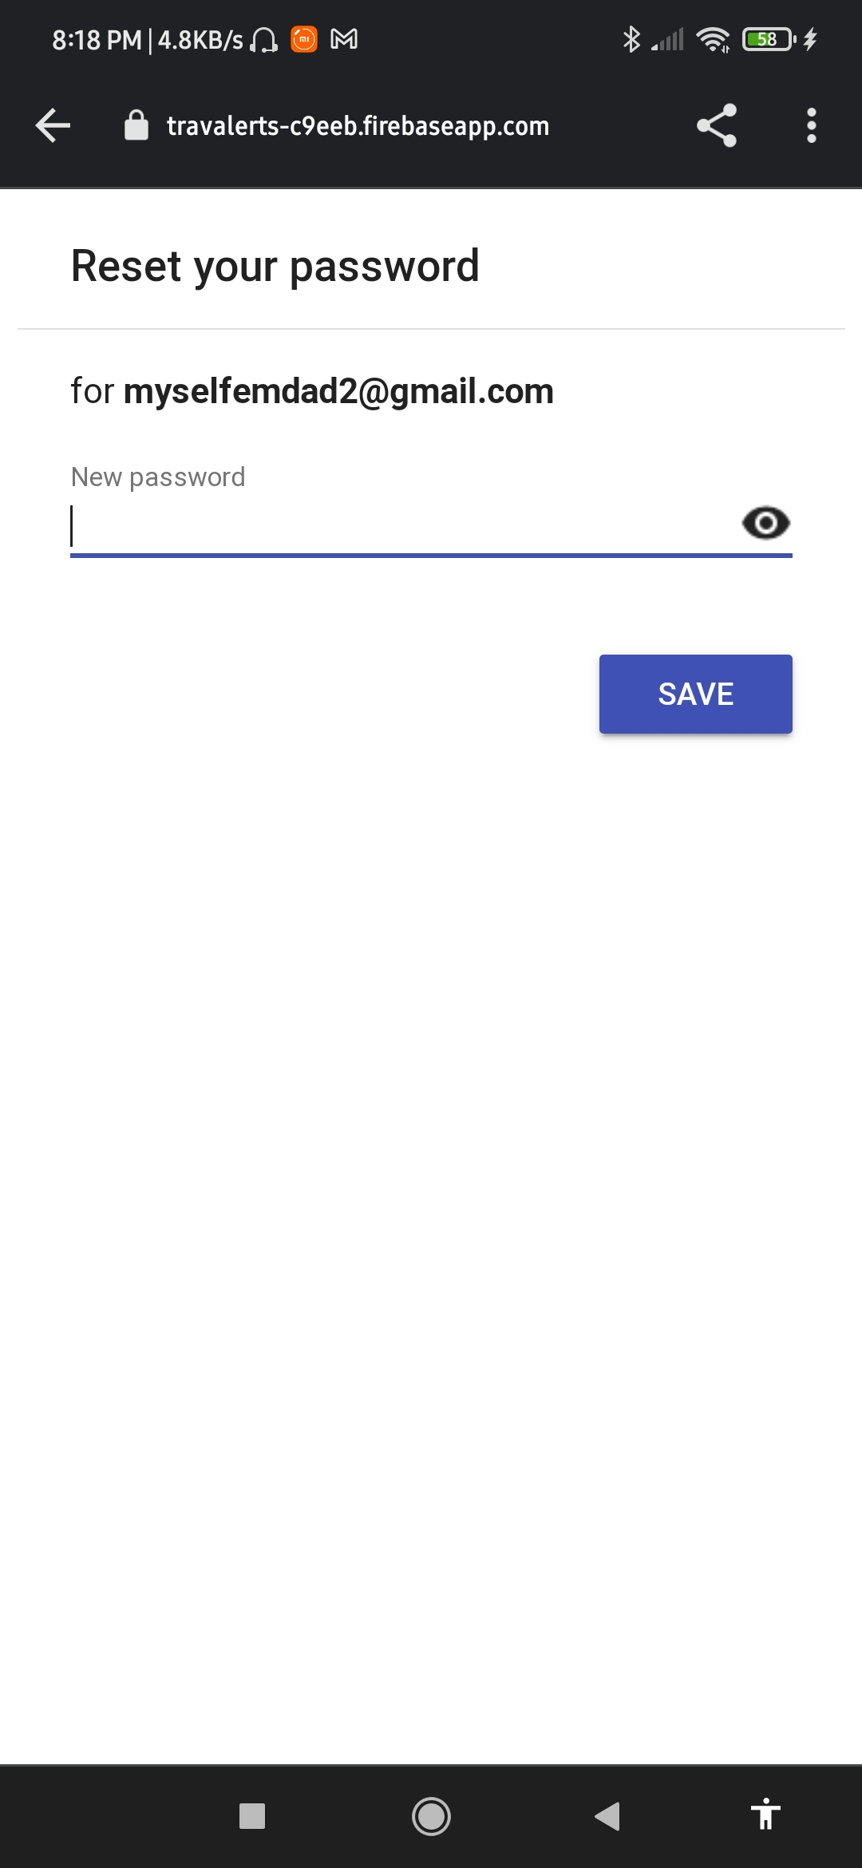

Figure 3.11: Password Change

(Source: App Screenshot)

The above figure 3.11 shows the change password procedure. If the user forget their password and they want to reset their password, they can change it by providing their email and clicking on the reset password link that is sent. Finally provide the new password on the new page.

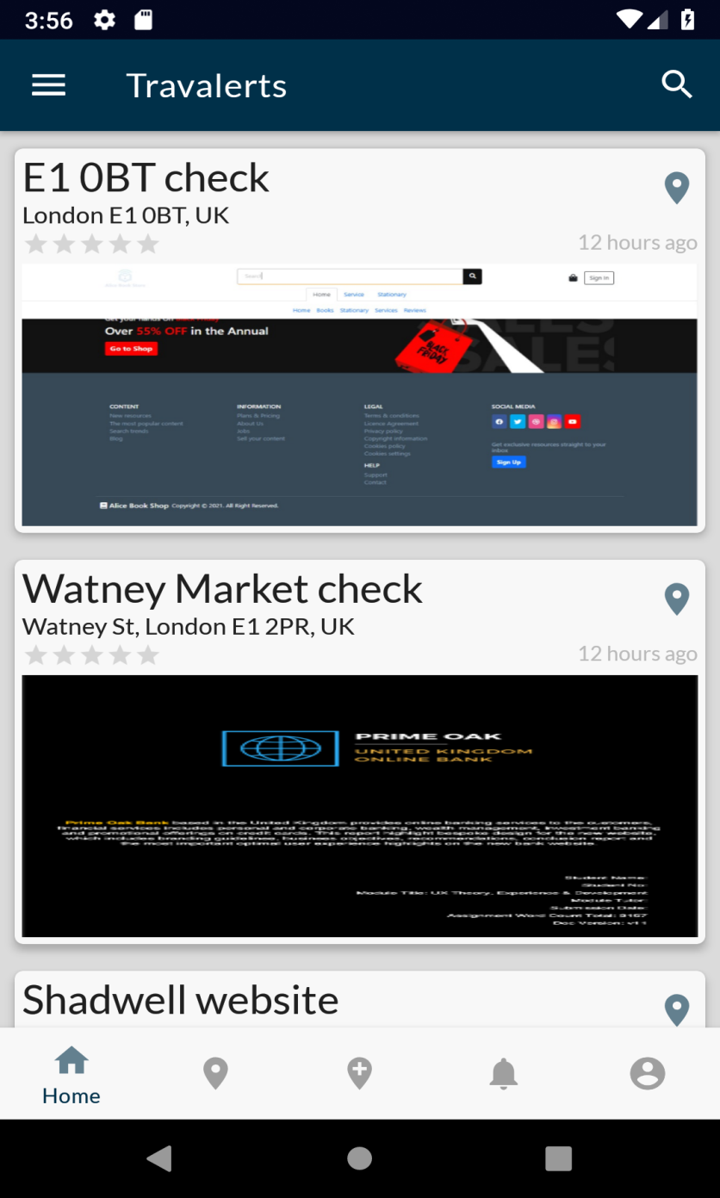

Figure 3.12: Home page

(Source: Self-created)

The above figure 3.12 shows the home page of the app, which suggests different tourist location nearby. Users can check all this option by clicking on them.

|  |  |
| --- | --- |
| Figure 3.13: **Description of palace**  (Source: Self-created) | Figure 3.14: **Ratings and Review of Place** (Source: Self-created) |

The two figures 3.13 and figures 3.14 represent the pages of the app which shows the description of the places. Figure 16 describes all about the location and distance of the placed from the users and the figures 3.15 shows the ratings and comments about the places, the user also can share their experience from the location of the palace.

|  |  |
| --- | --- |
| Figure 3.15: **Add Place**  (Source: Self-created) | Figure 3.16: Location Description  (Source: Self-created) |

The above two figures figure 3.15 and 3.16 are represents the features of add location and choosing of the location. People can choose tourist spots sound their circles and choose the locations from the list of the options. If a visitors add the name of a place in the app, then it will show the information about the place from its stored data, which was stored from user’s data. The visitors can able to see the description of the location with address, reviews, and ratings.

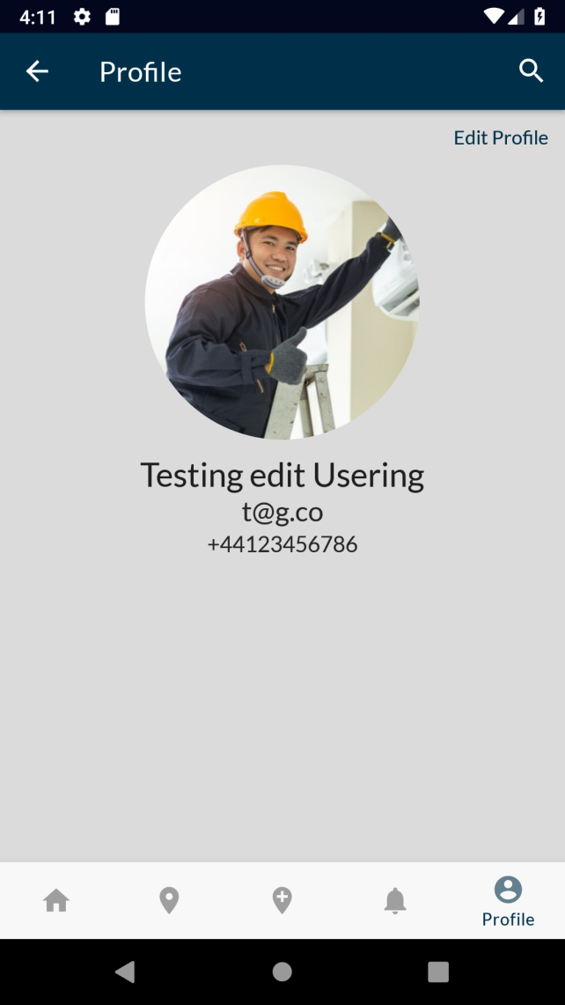

Figure 3.17: Profile Page

(Source: Self-created)

The above figure 3.17 shows the user profile page of the app. This consists of the image of the user, email id, and mobile number.

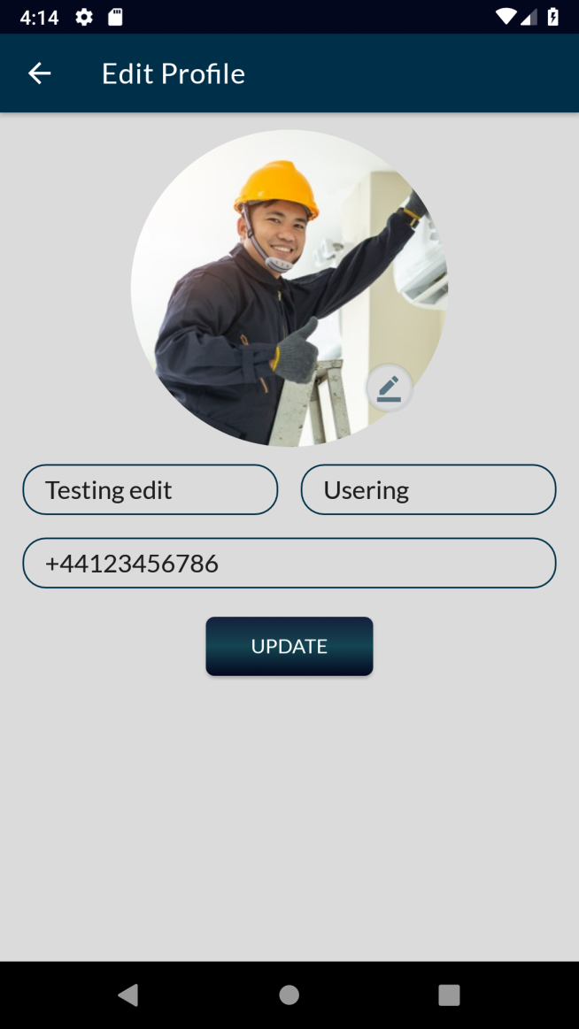

Figure 3.18: Edit Profile

(Source: Self-created)

The above figure 3.18 shows the edit profile page of the app. The profiles of the registered user of the app can be edited. They can change their profile picture, email id, and mobile number. And can also update the app in this page.

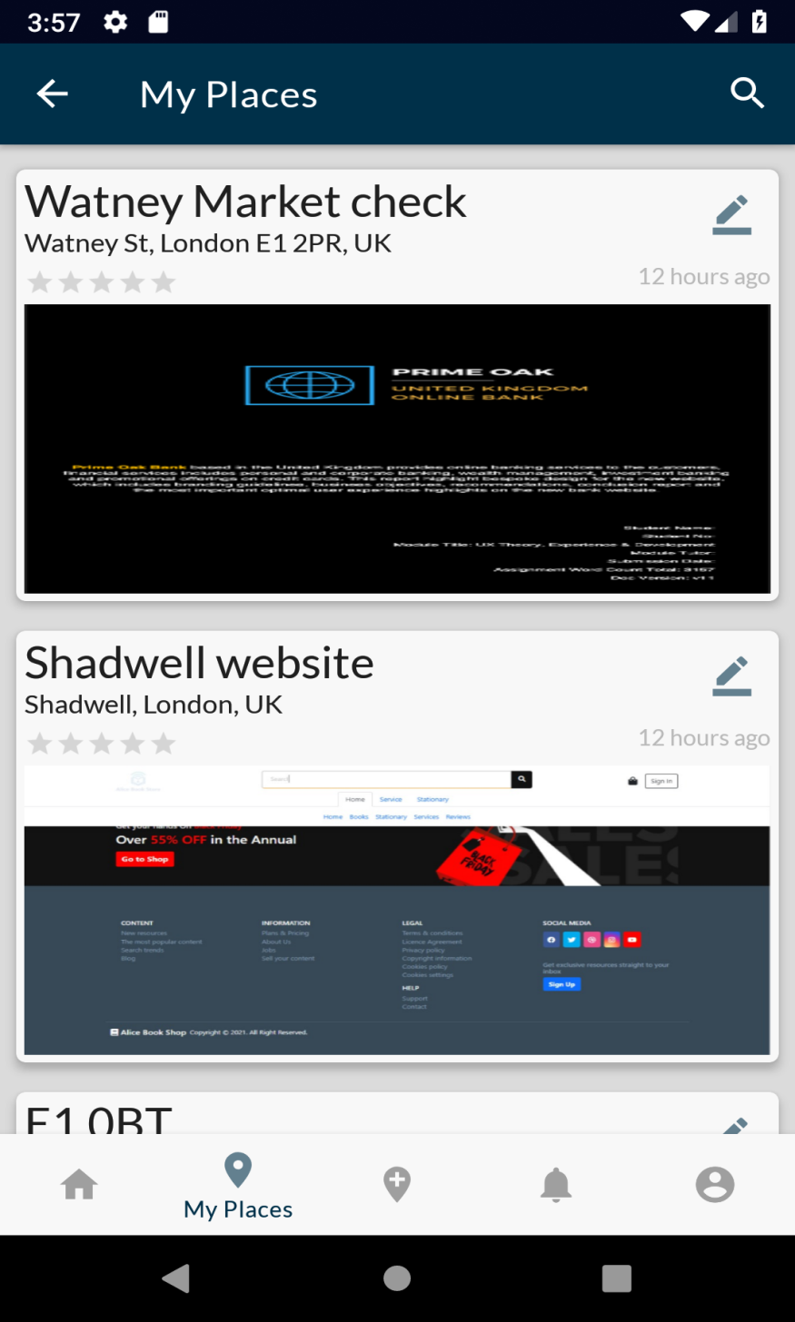

Figure 3.19: My Place

(Source: Self-created)

The above figure 3.19 shows the My place of the app, which store all the location which the user visited with ratings and there is also has an editing option. The users can add their comment about the place.

|  |  |
| --- | --- |
| Figure 3.20: Notification Page  (Source: Self-created) | Figure 3.21: Notification from the App  (Source: Self-created) |

The above figure 3.20 shows the notification page of the app. In this section all the notification about the visited palace is given. There is an option, where user can share their experience in the app. The notification about the visited place with entry and exit time. The figure 3.21 shows the notification came from the app to the mobile phone of the user.

|  |  |
| --- | --- |
| Figure 3.22: **Search Options**  (Source: Self-created) | Figure 3.23: L **Search Options**  (Source: Self-created) |

The above figure 3.22 and 3.23 represents the search option of the app, where users can search any location by the name of the palace or the location of the pace.

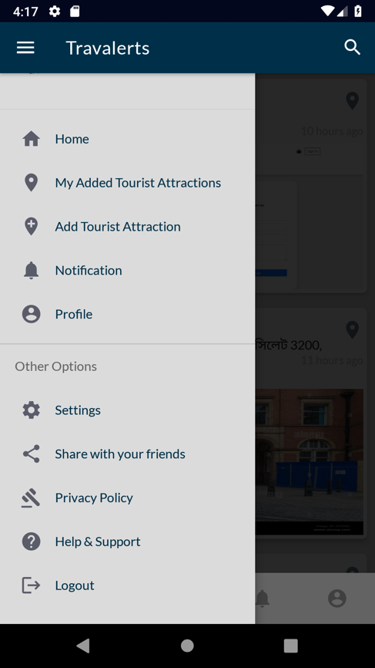

Figure 3.24: Sharing Option

(Source: Self-created)

The above figure 3.24 shows that the drawer of the app. Users can easily navigate through different screens from the drawer.

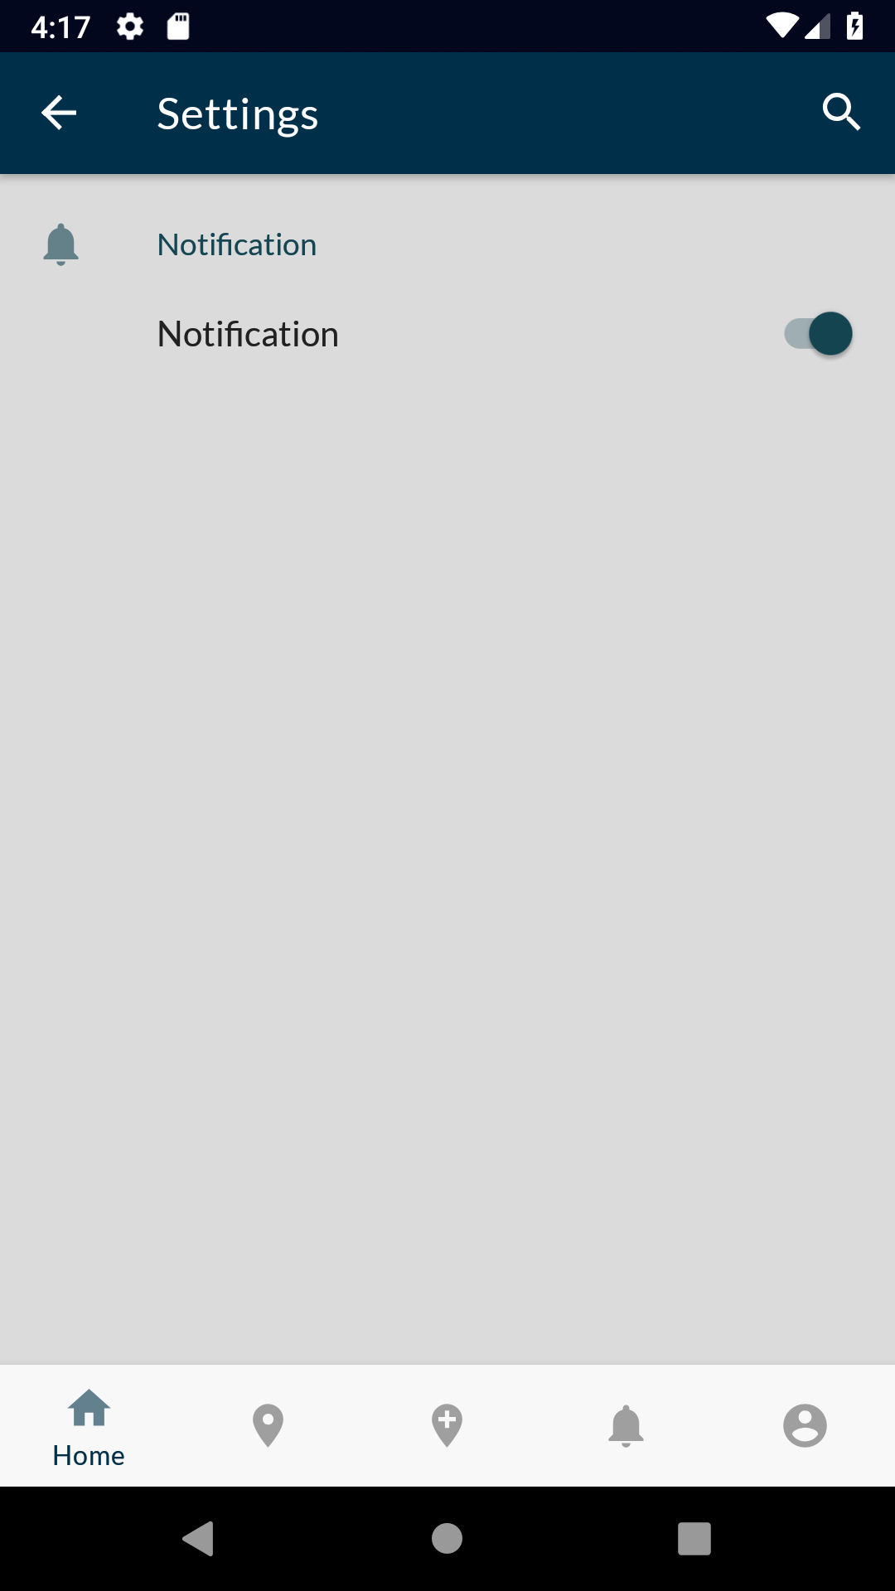

Figure 3.25: Settings Option

(Source: Self-created)

The above figure 3.25 shows the settings feature of the app where users can change the settings of the app like enable or disable notification.

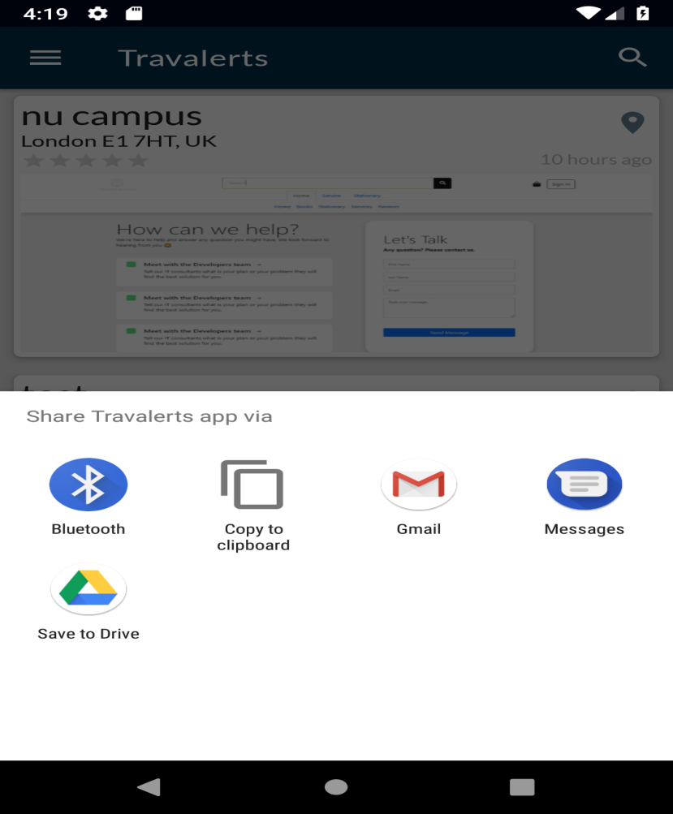

Figure 3.26: Sharing Option

(Source: Self-created)

The App can be shared through different apps such as Bluetooth, Gmail, messages, and it can also be saved in the Google drive. The app can be shared by the anyone be it registered user or just visitor of the app.

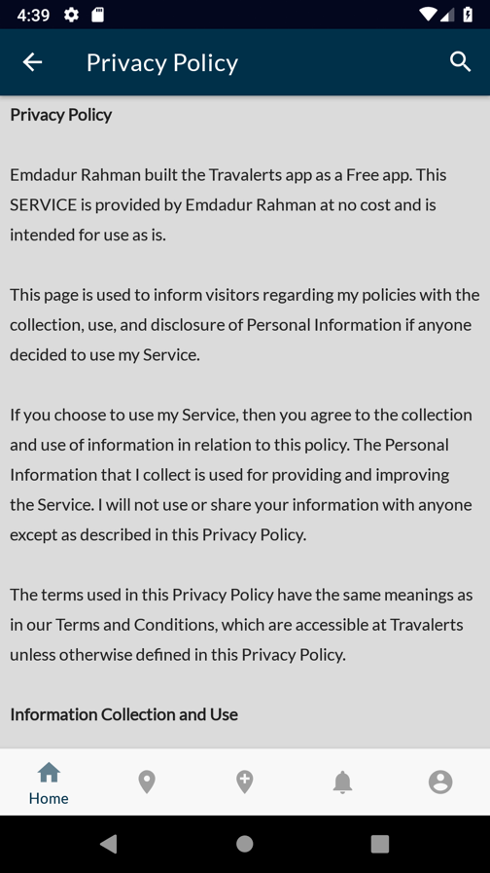

Figure 3.27: Privacy Policy

(Source: Self-created)

The Google Play Developer policy requires all of android application that collect and handles users’ personal data must have a Privacy Policy in place.

It is mandatory for this app to have privacy policy screen. Figure 3.27 shows privacy policy screen.

**Part 4**

**DEPLOYMENT**

Part 4

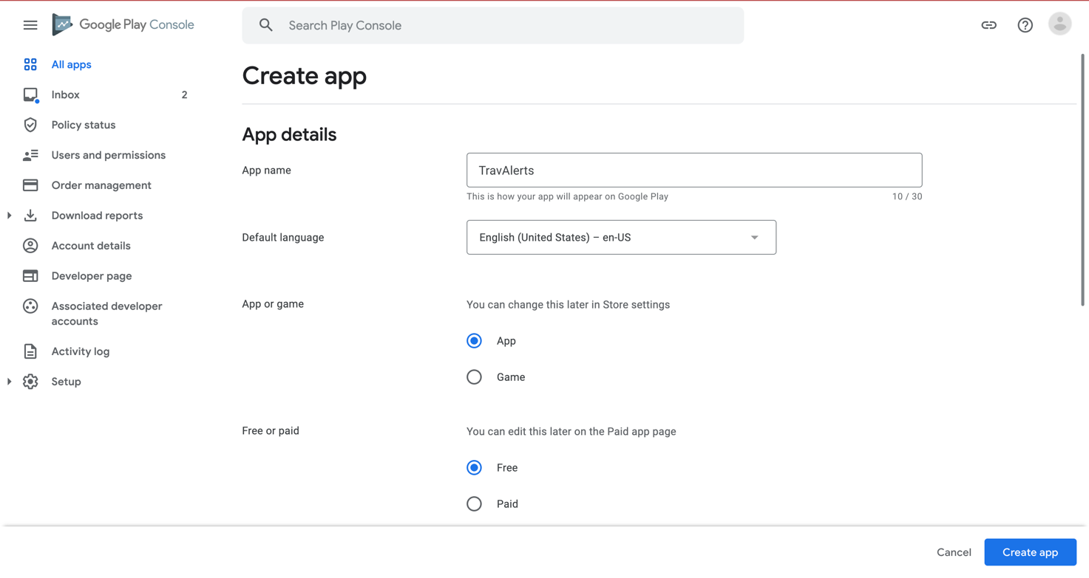

Figure 4.1: Add App on The Play Console Dashboard

(Source: Google play console Screenshot)

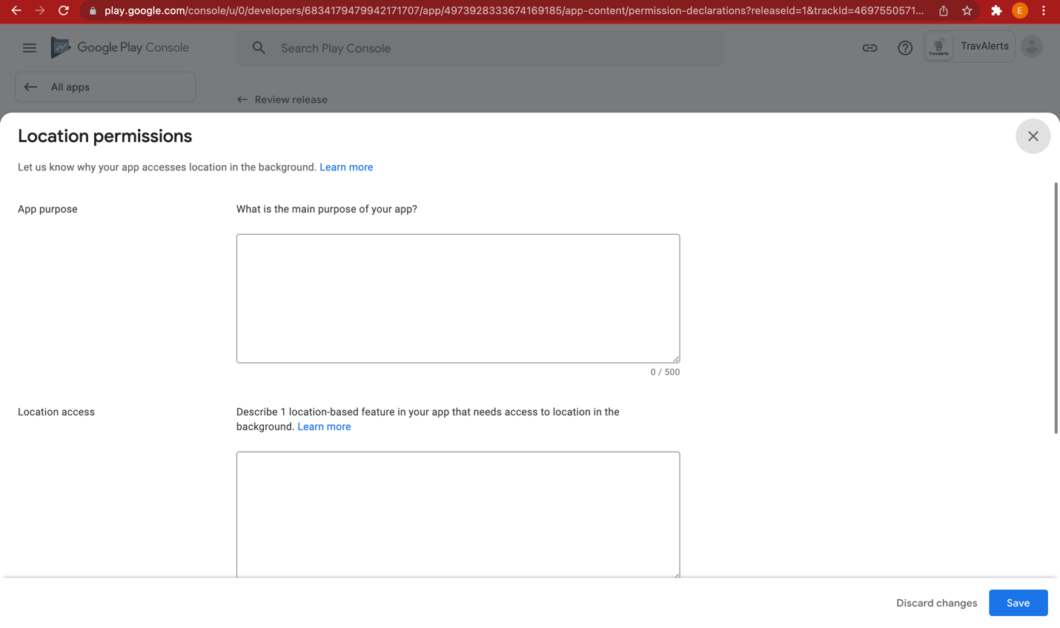

Figure 4.2: App release steps

(Source: Google play console Screenshot)

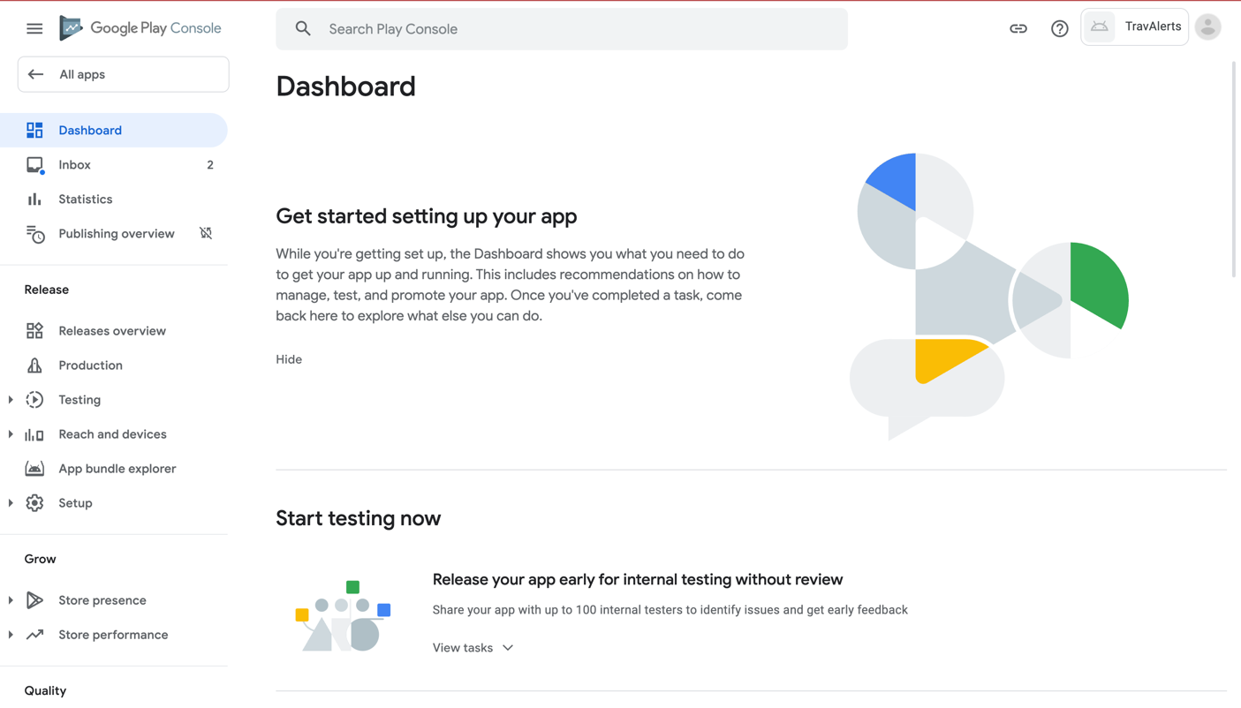

Figure 4.3: App release steps

(Source: Google play console Screenshot)

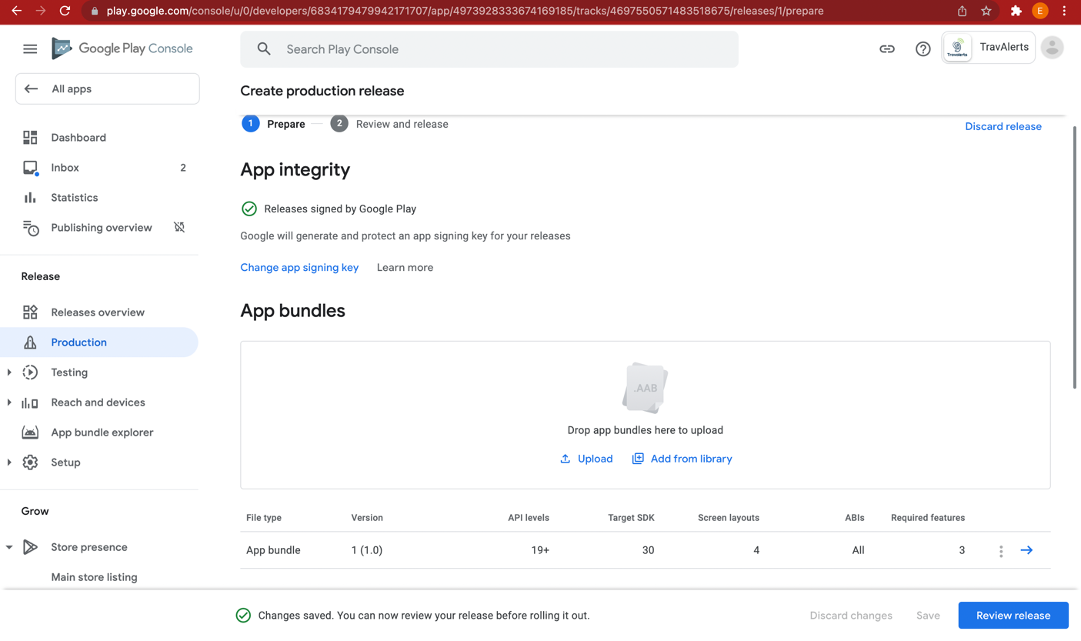

Figure 4.4: Uploading App Bundle On The Google Play Console

(Source: Google play console Screenshot)

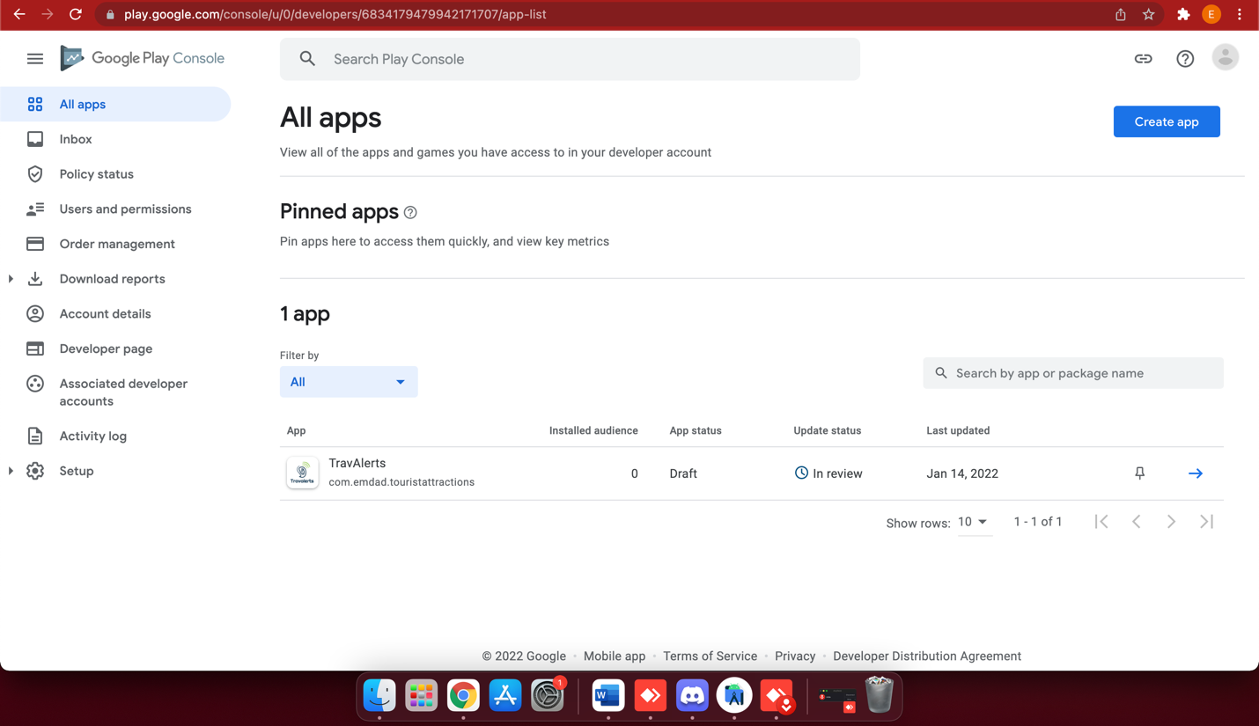

Figure 4.5: App in Review for Publish

(Source: Google play console Screenshot)

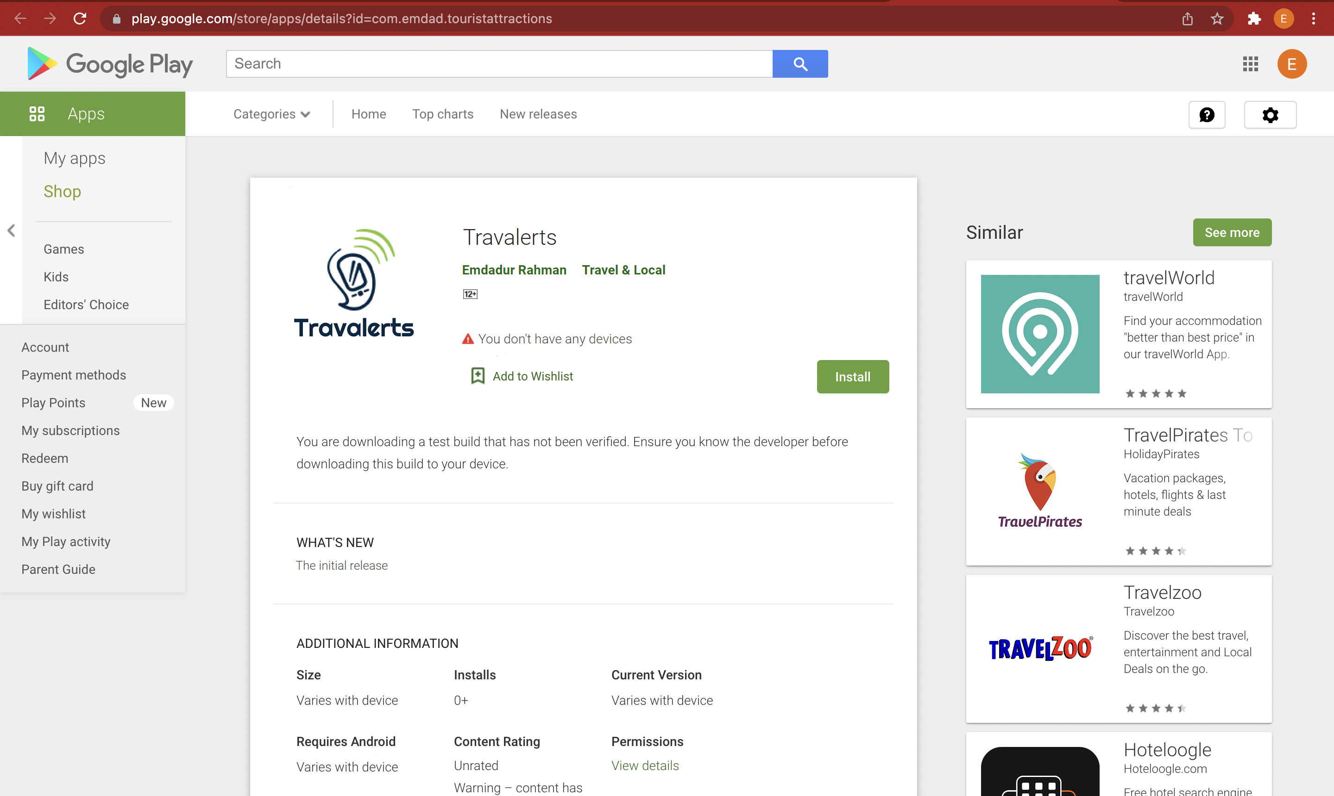

Figure 4.6: App published in Google Play store

(Source: Google Play Store Screenshot)

# References

**Journal**

Bai, J., Xie, S., Zhang, X., Fang, S., Li, Z. and Nian, W., 2021, August. Architecture design of wireless access system in power grid application scenario based on 5th Generation Mobile Communication Technology small base station. In *Journal of Physics: Conference Series* (Vol. 2005, No. 1, p. 012011). IOP Publishing.

Hussain, M., Al-Haiqi, A., Zaidan, A.A., Zaidan, B.B., Kiah, M., Iqbal, S., Iqbal, S. and Abdulnabi, M., 2018. A security framework for mHealth apps on Android platform. *Computers & Security*, *75*, pp.191-217.

Ibrahim, A.N. and Abdullah, M.F.L., 2017, September. The potential of FBMC over OFDM for the future 5G mobile communication technology. In *AIP Conference Proceedings* (Vol. 1883, No. 1, p. 020001). AIP Publishing LLC.